Format to report your ADVANCED JAVA PROGRAMMING PROJECTS

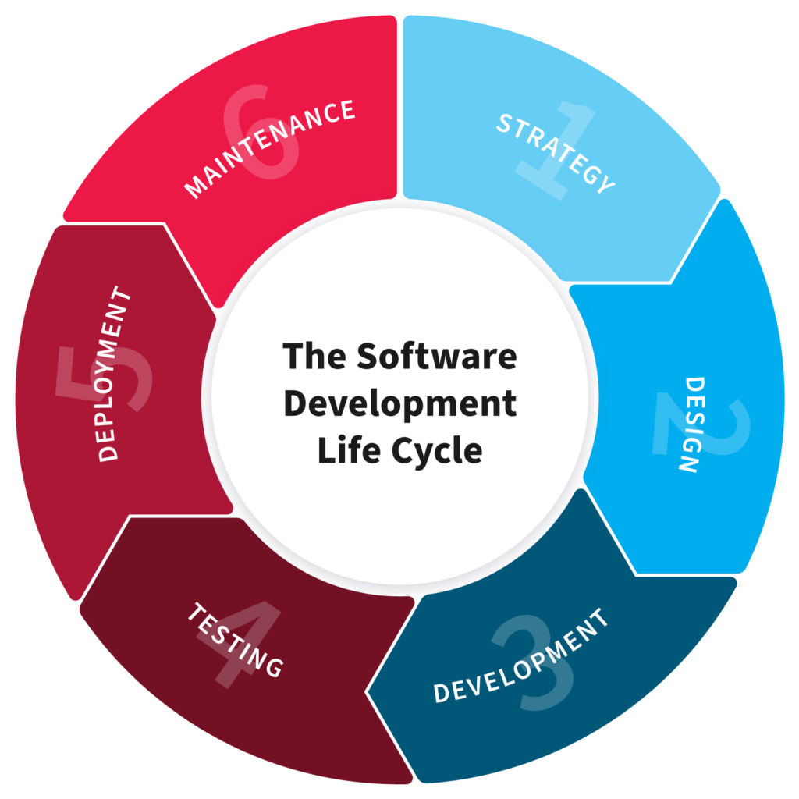

NB: EVERY STUDENTS HAS TO PRODUCE THIS DOC

NAME:
REG NO:
CLASS NO:

PROJECT NAME:

1.PLANNING

“In this Section, Students, have to define the system ( your projects) goals and objectives and the problems the future system needs to solve.”

2. Design

“In this Section, students needs to elaborate how the system will work, focusing on software design and how it works with the technical and functional requirements of the system. Depicts also how your team defined how users will interact with the software.”

3. Development

“ In this Section, Students need to elaborate how they build the entire system( Front end- back end technologies), chosen libraries, platforms, storage and databases, adopted technologies, etc...”

4.Testing

“ In this Section, Students to show the way this stage was conducted. Ensuring that everything works as expected. Which defects and bugs you found, and how did you fixed them to ensure that the product meets the original specifications.”

5.Deployment

“ In this Section, Students have to describe how, installation, testing, deployment, and performance monitoring were conducted in their own respective laptop or desktop . “

